**The reaction of curcumin-hydrazine and its effect on bone marrow mesenchymal stem cells**

Sabah Salahvarzia,*, Keyhan Mohammadpoura, Zeynab Dadgarb

a*Department of Chemistry, Faculty of Science, Khorramabad Branch, Islamic Azad University, Khorramabad, Iran*

*b Department of biology, Faculty of Science, Arak University, Arak, Iran*



**Figure S2.** IR spectrum of curcumin-hydrazine interaction (stirrer)

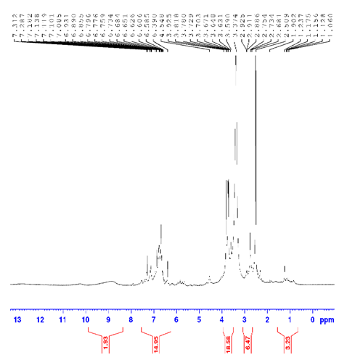

**Figure S3.** 1H NMR spectrum of curcumin-hydrazine interaction (stirrer)

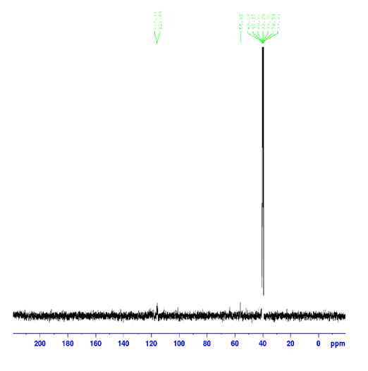

**Figure S4.** 13C NMR spectrum of curcumin-hydrazine interaction (stirrer)

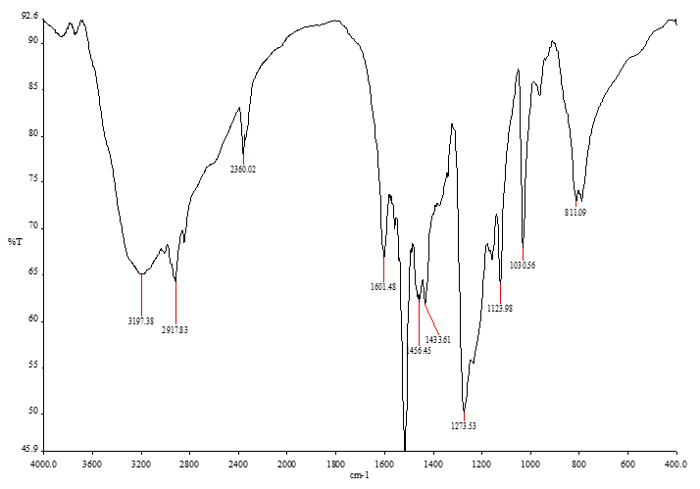

**Figure S5.** IR spectrum of curcumin-hydrazine interaction (ultra)

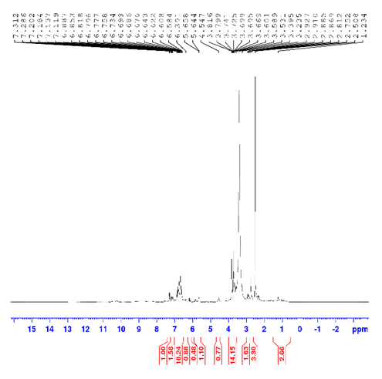

**Figure S6.** 1H NMR spectrum of curcumin-hydrazine interaction (ultra)

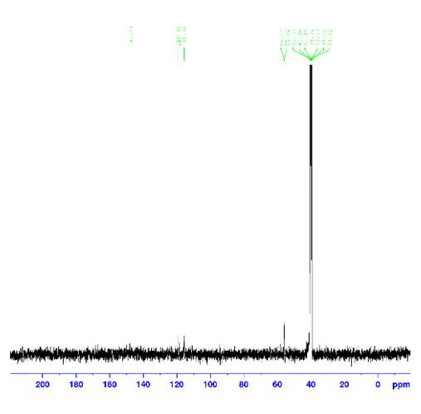

**Figure S7.** 13C NMR spectrum of curcumin-hydrazine interaction (ultra)

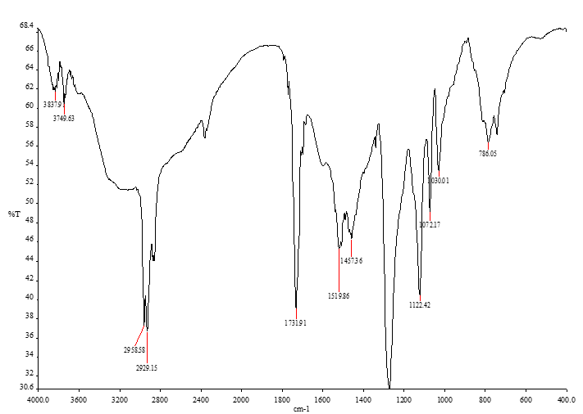

**Figure S8.** IR spectrum of curcumin-hydrazine interaction (reflux)