**Asian Journal of Nanoscience and Materials, 2018, 1(3).**

**Supplementary Information**

**One Pot synthesis of 2-substituted benzothiazoles catalyzed by Bi2O3 nanoparticles**

**Jyoti Sharma*, Ravi Bansal, Pradeep Soni, Swati Singh and Anand. K. Halve**

*School of studies in chemistry, Jiwaji University, Gwalior (M.P.) India-474011*

**Received: 28 March 2018, Revised: 05 May 2018 and Accepted: 09 May 2018.**

|  |
| --- |
| **ABSTRACT:** A convenient and efficient synthesis of the 2-substituted benzothiazole derivatives were carried out by the one-pot reaction of 2-aminothiophenol with various aromatic aldehydes in using Bi2O3 nanoparticles as a catalyst at 60 °C. The structures of the synthesized compounds were confirmed by FT-IR, H1 NMR, C13 NMR, Mass spectrometry, and elemental analysis. This protocol revealed some advantages including, purification of the products by non-chromatographic method. Bi2O3 nanoparticles are cheap, readily available, versatile, environment friendly and recyclable. The reaction was carried out in ethanol, eliminating the hazardous organic solvents.**KEYWORDS:** Benzothiazole derivatives, Synthesis, Bi2O3, Catalyzed and Nano-particles, One Pot. |
| **GRAPHICAL ABSTRACT:** |

**Table of contents:**

1. FTIR Spectra of 2-phenyl-1,3-benzothiazole (1a).
2. 1H NMR Spectra of 2-phenyl-1,3-benzothiazole (1a) .
3. 13C NMR Spectra of 2-phenyl-1,3-benzothiazole (1a).
4. Mass spectra of 2-phenyl-1,3-benzothiazole (1a).
5. FTIR of 2-(4-methoxyphenyl)-1,3-benzothiazole (1b).
6. 1H NMR Spectra of 2-(4-methoxyphenyl)-1,3-benzothiazole (1b).
7. 13C NMR Spectra of 2-(4-methoxyphenyl)-1,3-benzothiazole (1b).
8. Mass spectra of 2-(4 methoxyphenyl)-1,3-benzothiazole (1b).
9. FTIR Spectra of 2-(4-fluorophenyl)-1,3-benzothiazole (1c).
10. 1H NMR Spectra of 2-(4-fluorophenyl)-1,3-benzothiazole (1c).
11. 13C NMR Spectra of 2-(4-fluorophenyl)-1,3-benzothiazole (1c).
12. Mass Spectra of 2-(4-fluorophenyl)-1,3-benzothiazole (1c).
13. FTIR Spectra of 2-(3-nitrophenyl)-1,3-benzothiazole (1d).
14. 1H NMR Spectra of 2-(3-nitrophenyl)-1,3-benzothiazole (1d).
15. 13C NMR Spectra of 2-(3-nitrophenyl)-1,3-benzothiazole (1d).
16. Mass Spectra of 2-(3-nitrophenyl)-1,3-benzothiazole (1d).
17. FTIR Spectra of 2-(2-nitrophenyl)-1,3-benzothiazole (1e).
18. 1H NMR Spectra of 2-(2-nitrophenyl)-1,3-benzothiazole (1e).
19. 13C NMR Spectra of 2-(2-nitrophenyl)-1,3-benzothiazole (1e).
20. Mass Spectra of 2-(2-nitrophenyl)-1,3-benzothiazole (1e).
21. FTIR Spectra of 2-(4-chlorophenyl)-1,3-benzothiazole (1f).
22. 1H NMR Spectra of 2-(4-chlorophenyl)-1,3-benzothiazole (1f).
23. 13C NMR Spectra of 2-(4-chlorophenyl)-1,3-benzothiazole (1f).
24. Mass Spectra of 2-(4-chlorophenyl)-1,3-benzothiazole (1f).
25. FTIR Spectra of 2-(4-chlorophenyl)-1,3-benzothiazole (1g).
26. 1H NMR Spectra of 2-(4-chlorophenyl)-1,3-benzothiazole (1g).
27. 13C NMR Spectra of 2-(4-chlorophenyl)-1,3-benzothiazole (1g).
28. Mass Spectra of 2-(4-chlorophenyl)-1,3-benzothiazole (1g).

**FTIR Spectra of 2-phenyl-1,3-benzothiazole (1a)**



3061.69cm-1, 45.78%T

**1H NMR Spectra of 2-phenyl-1,3-benzothiazole (1a)**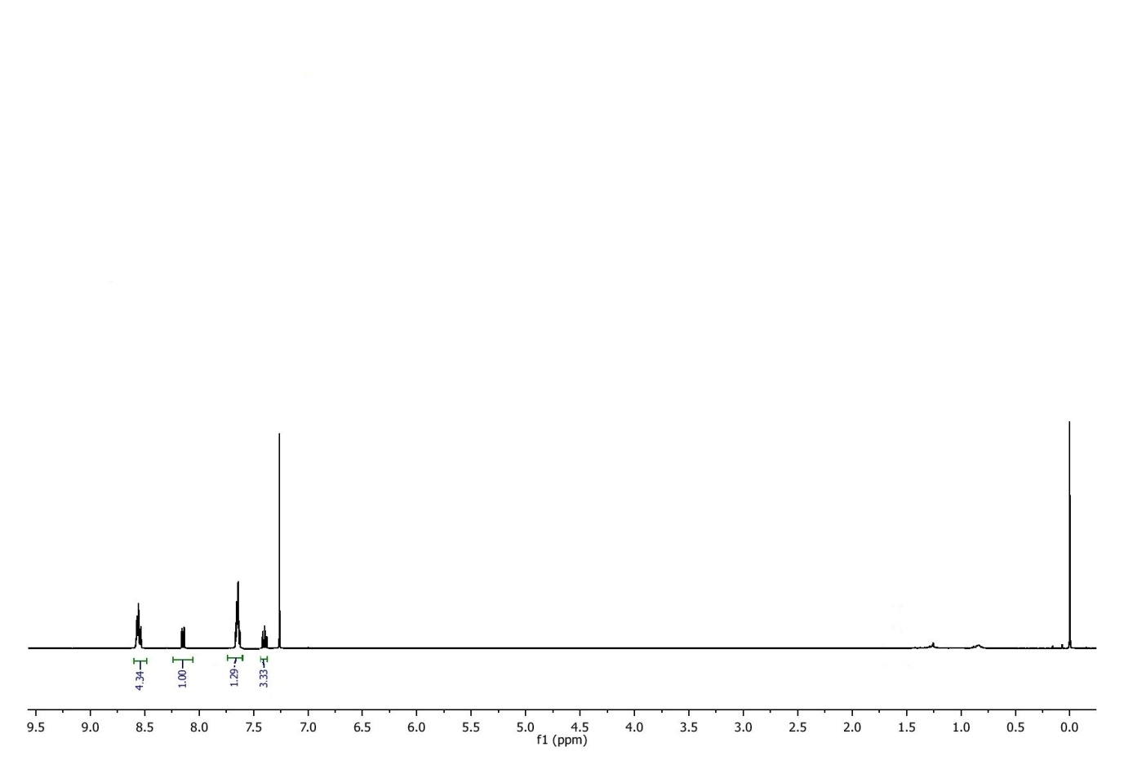

**13C NMR Spectra of 2-phenyl-1,3-benzothiazole (1a)** 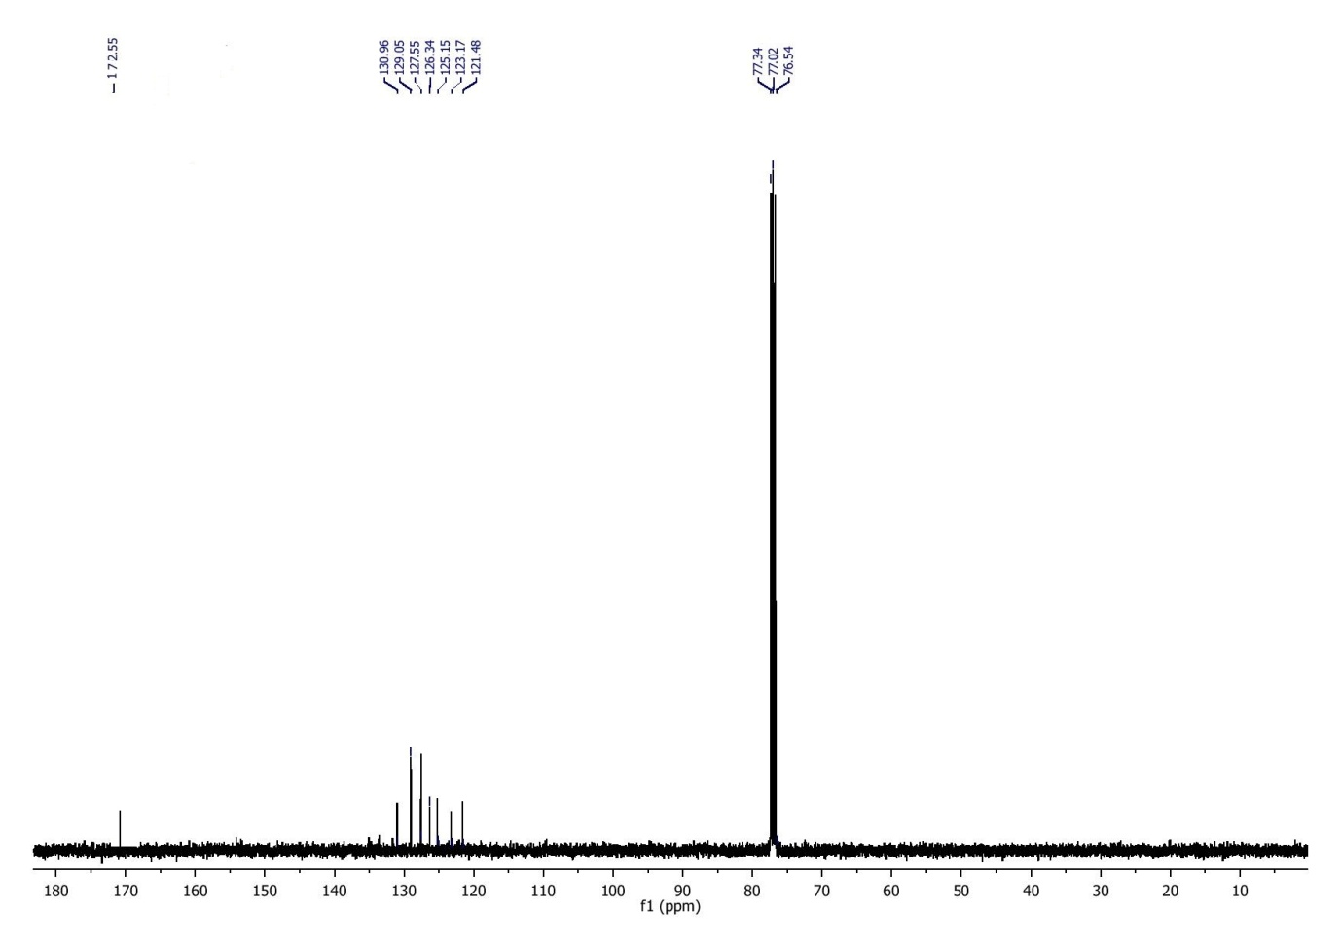

**Mass spectra of 2-phenyl-1,3-benzothiazole (1a)** 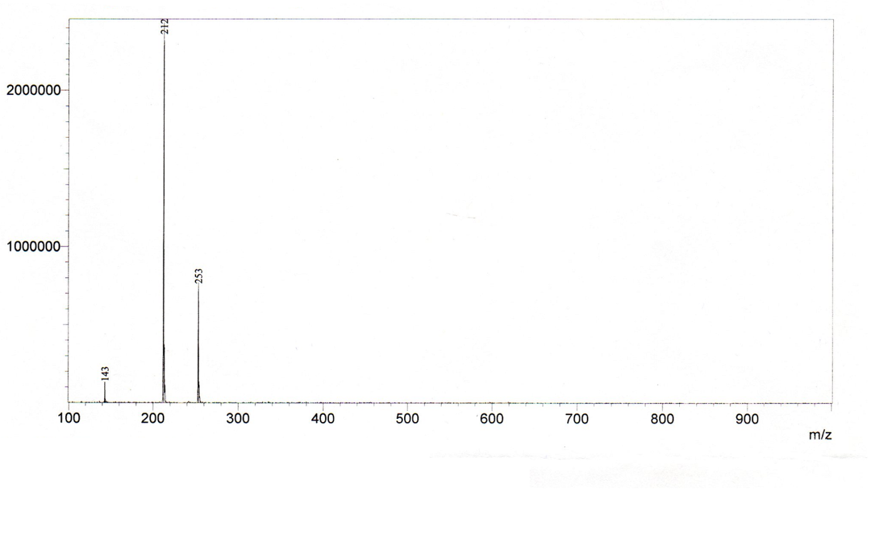

**FTIR of 2-(4-methoxyphenyl)-1,3-benzothiazole (1b)**

2926.43cm-1, 41.33%T

3061.69cm-1, 45.78%T

**1H NMR Spectra of 2-(4-methoxyphenyl)-1,3-benzothiazole (1b)**

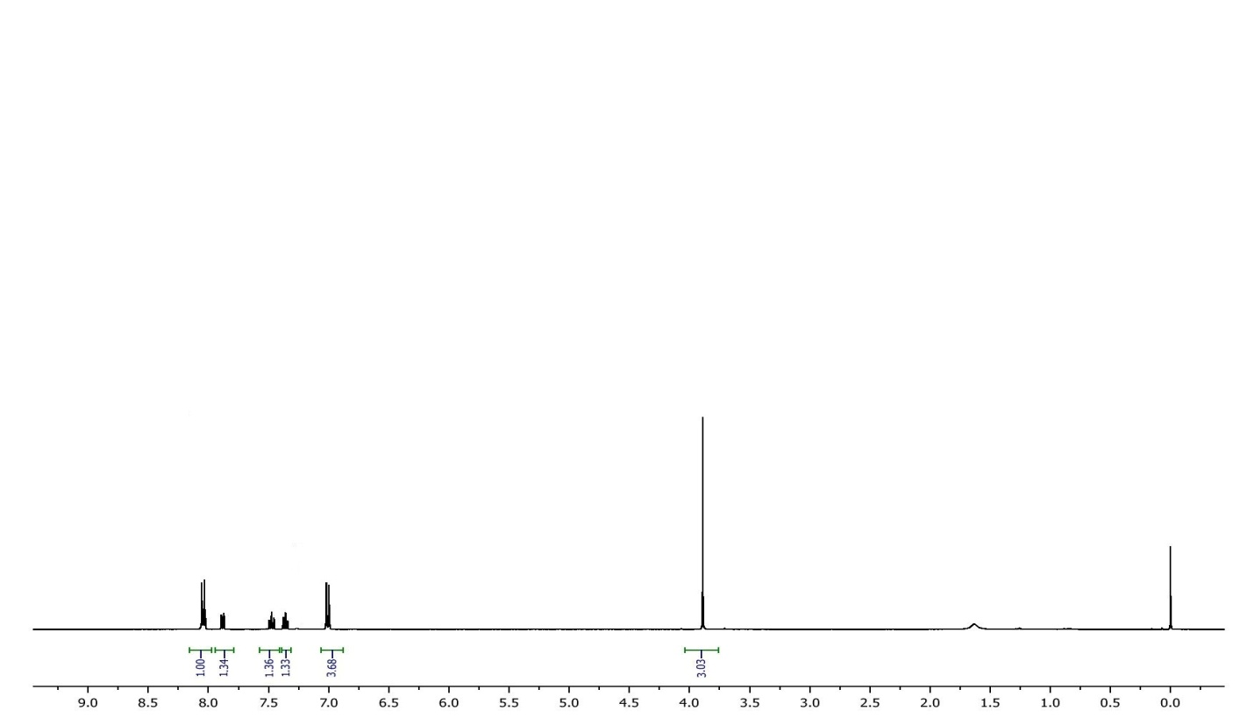

**13C NMR Spectra of 2-(4-methoxyphenyl)-1,3-benzothiazole (1b)**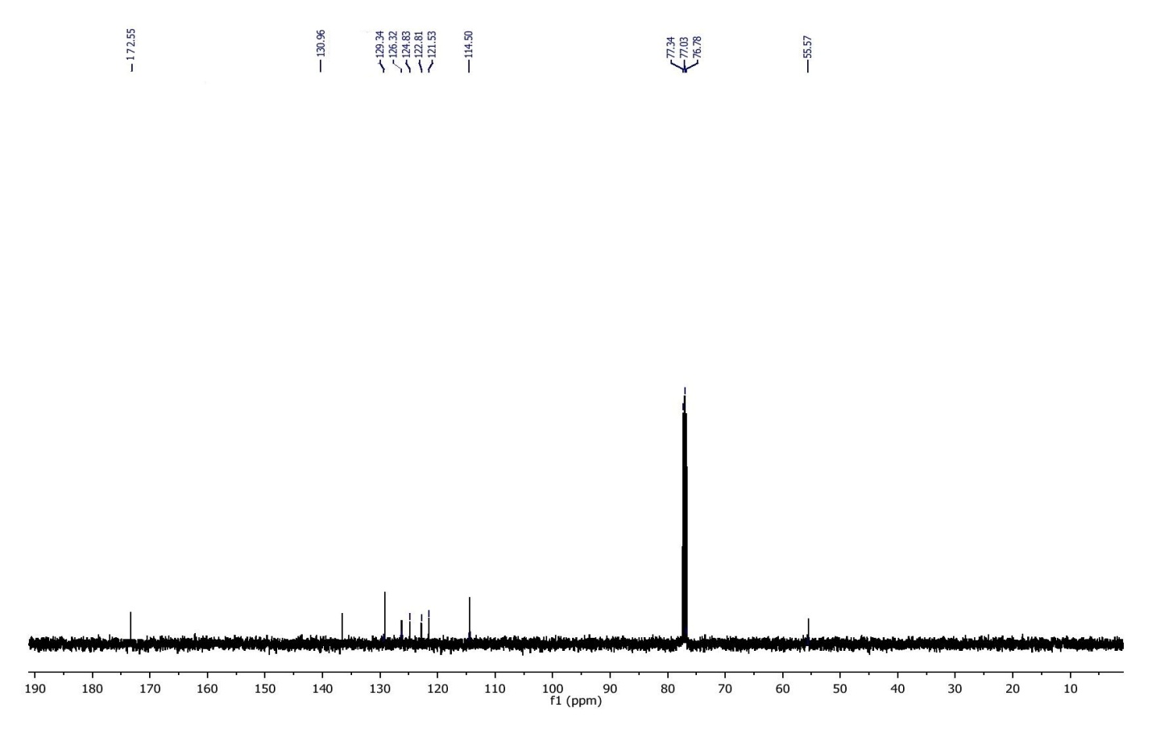

**Mass spectra of 2-(4-methoxyphenyl)-1,3-benzothiazole (1b)**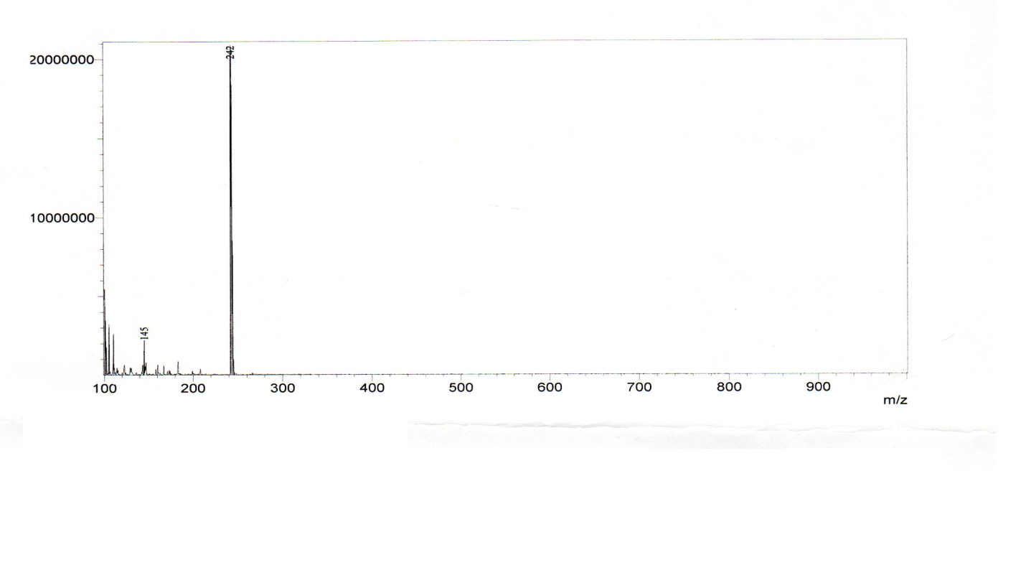

**FTIR Spectra of 2-(4-fluorophenyl)-1,3-benzothiazole** **(1c)**



3028.98cm-1, 59.33%T

**1H NMR Spectra of 2-(4-fluorophenyl)-1,3-benzothiazole (1c)** 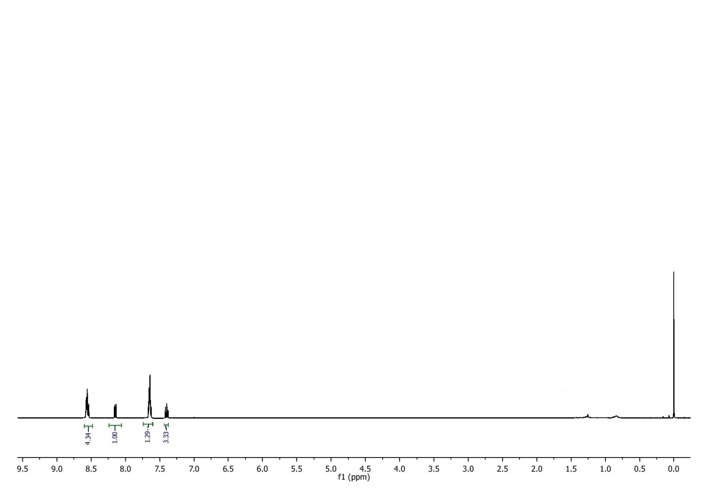

**13C NMR Spectra of** **2-(4-fluorophenyl)-1,3-benzothiazole (1c)**

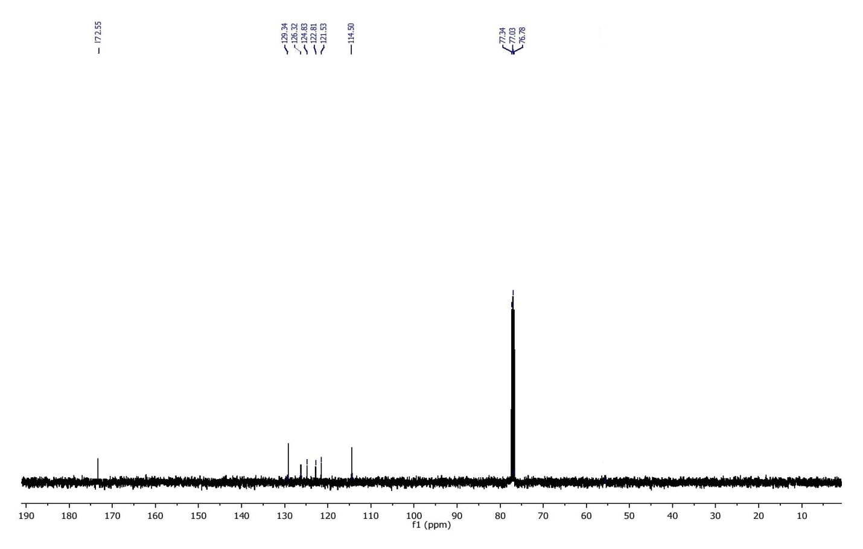

**Mass Spectra of 2-(4-fluorophenyl)-1,3-benzothiazole (1c)** 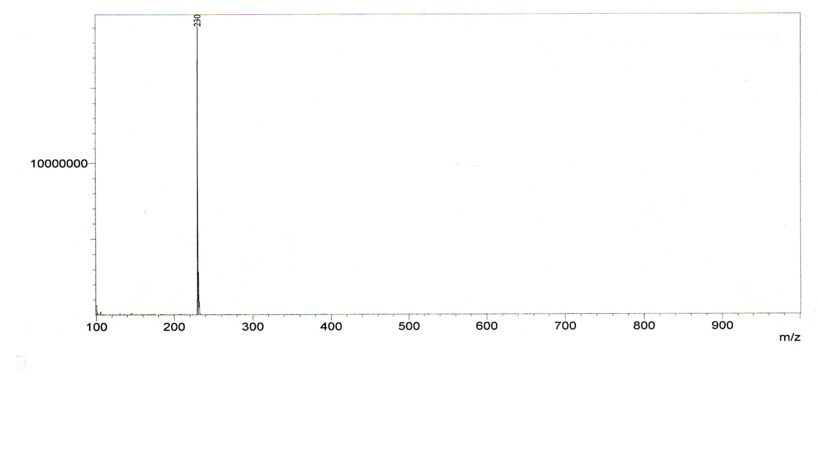

**FTIR Spectra of 2-(3-nitrophenyl)-1,3-benzothiazole (1d)**



3028.98cm-1, 59.33%T

**1H NMR Spectra of 2-(3-nitrophenyl)-1,3-benzothiazole (1d)**

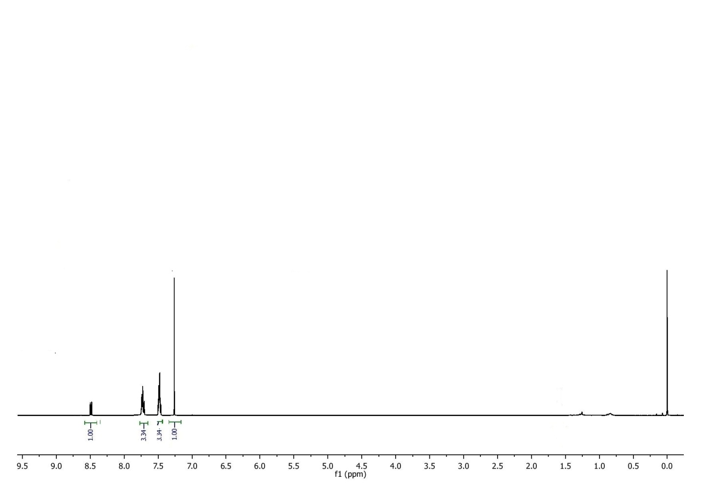

**13C NMR Spectra of 2-(3-nitrophenyl)-1,3-benzothiazole (1d)**

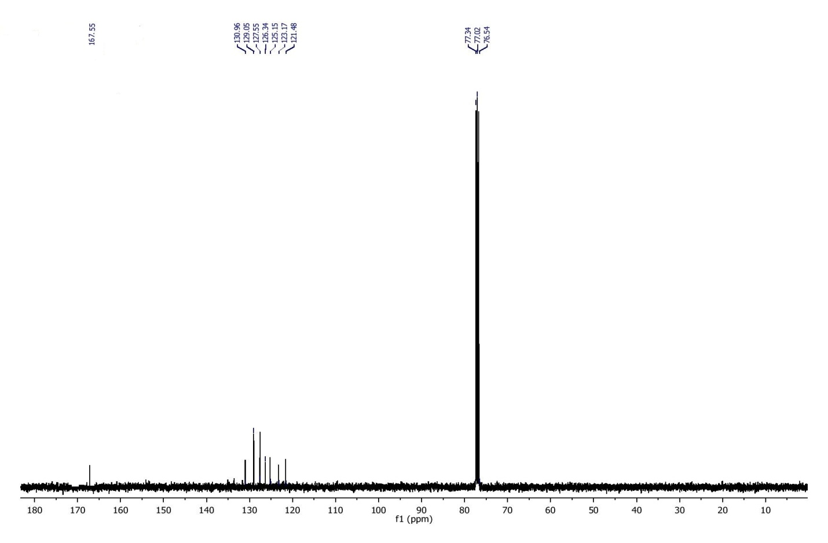

**Mass Spectra of 2-(3-nitrophenyl)-1,3-benzothiazole (1d)**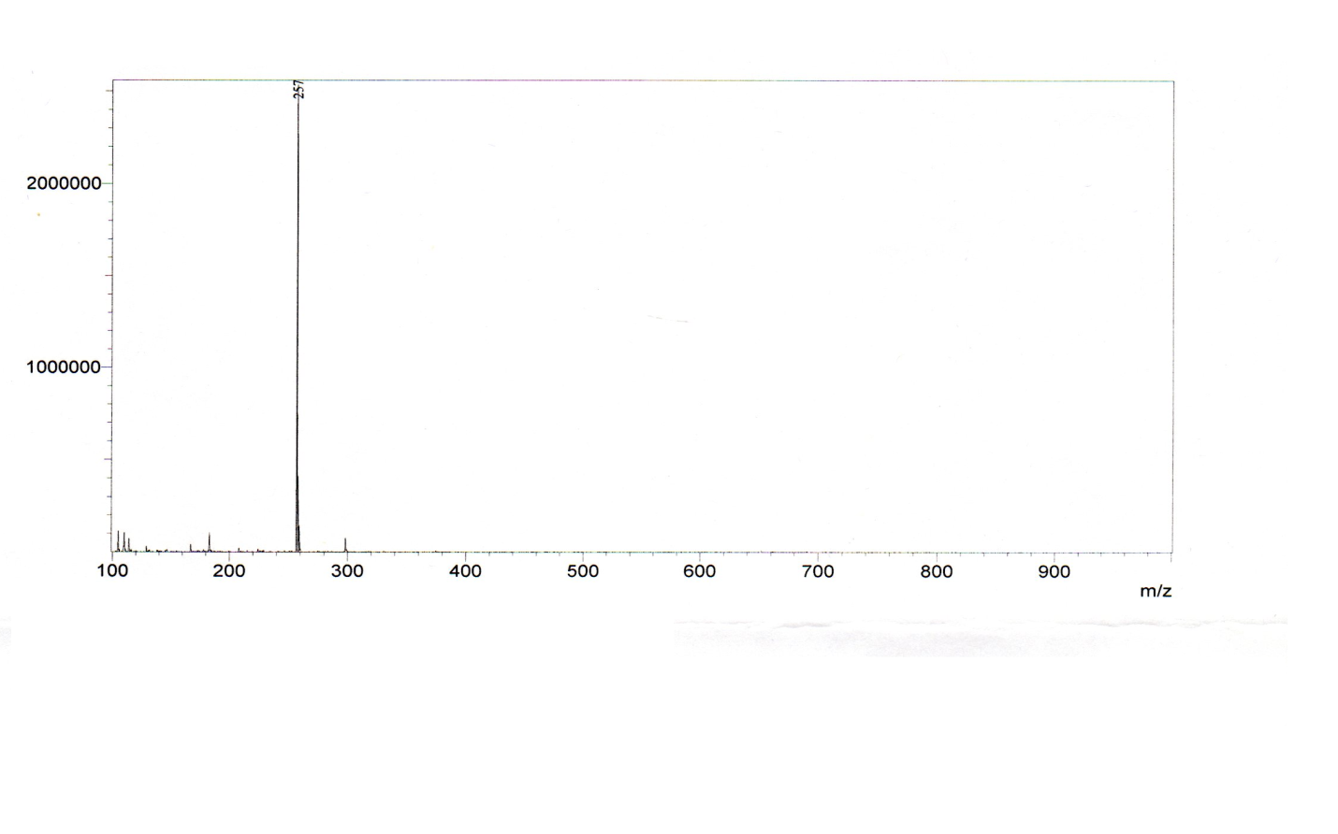

**FTIR Spectra of 2-(2-nitrophenyl)-1,3-benzothiazole (1e)**

3028.98cm-1, 59.33%T

5_1

Name

Sample 036 By Administrator Date Tuesday, May 02 2017

Description

4000

400

3500

3000

2500

2000

1500

1000

500

72

14

15

20

25

30

35

40

45

50

55

60

65

70

cm-1

%T

1533.18cm-1, 17.39%T

761.67cm-1, 21.87%T

754.41cm-1, 24.01%T

1367.76cm-1, 27.48%T

973.29cm-1, 32.69%T

783.62cm-1, 32.75%T

731.92cm-1, 33.66%T

717.52cm-1, 35.70%T

703.98cm-1, 36.79%T

1304.43cm-1, 37.22%T

1470.75cm-1, 38.34%T

1430.95cm-1, 39.02%T

1455.72cm-1, 40.82%T

1231.58cm-1, 41.73%T

681.78cm-1, 41.87%T

1240.85cm-1, 42.60%T

**1H NMR Spectra of 2-(2-nitrophenyl)-1,3-benzothiazole (1e)**

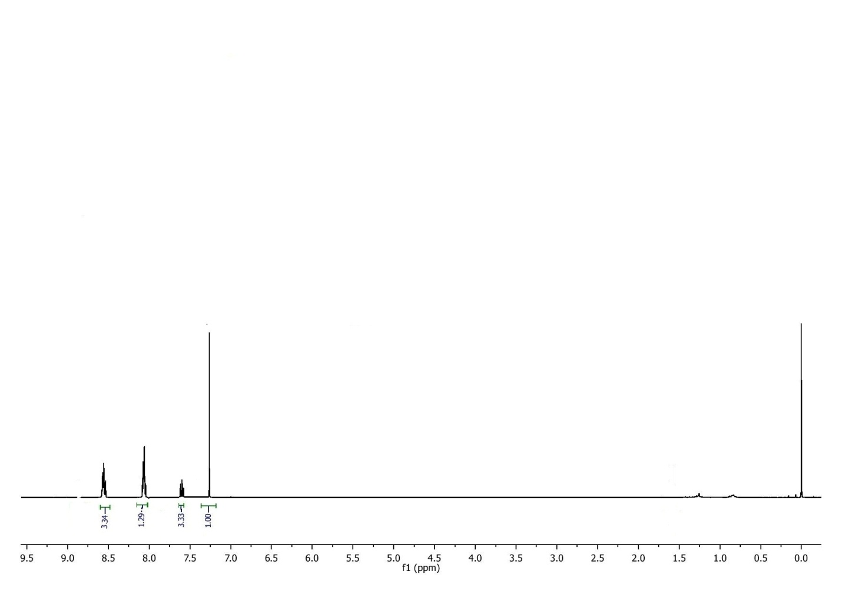

**13C NMR Spectra of 2-(2-nitrophenyl)-1,3-benzothiazole (1e)**

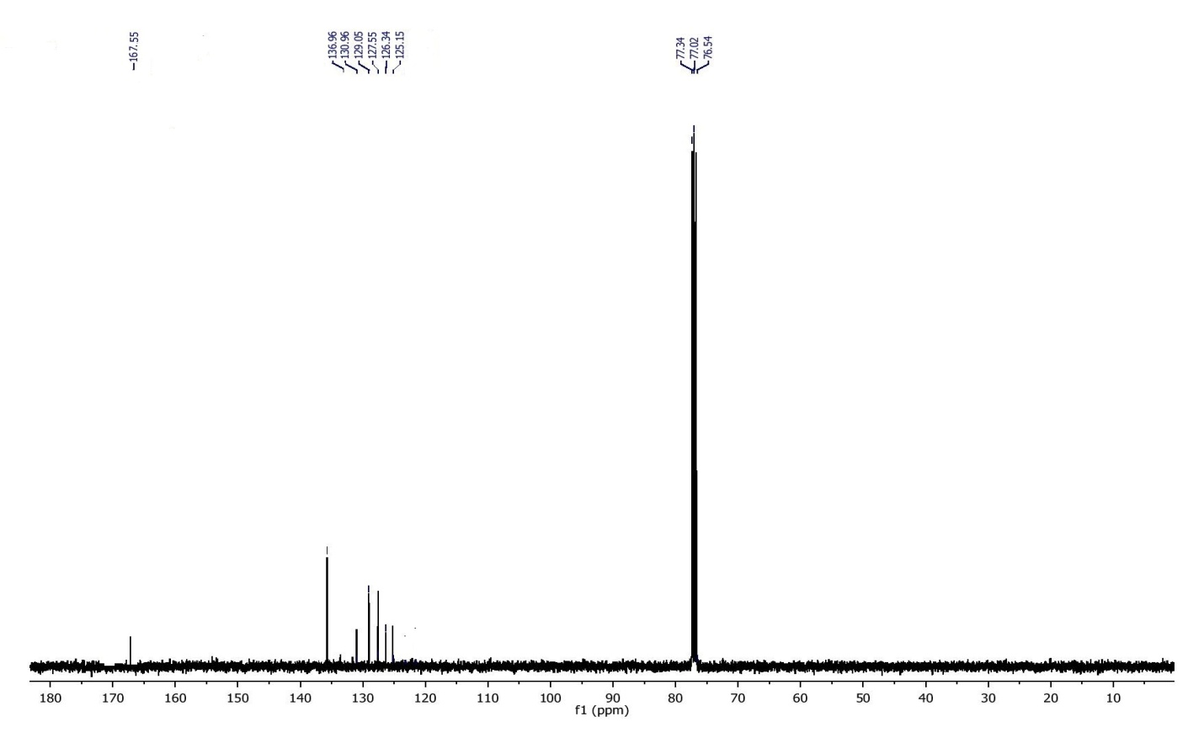

**Mass Spectra of 2-(2-nitrophenyl)-1,3-benzothiazole (1e)** 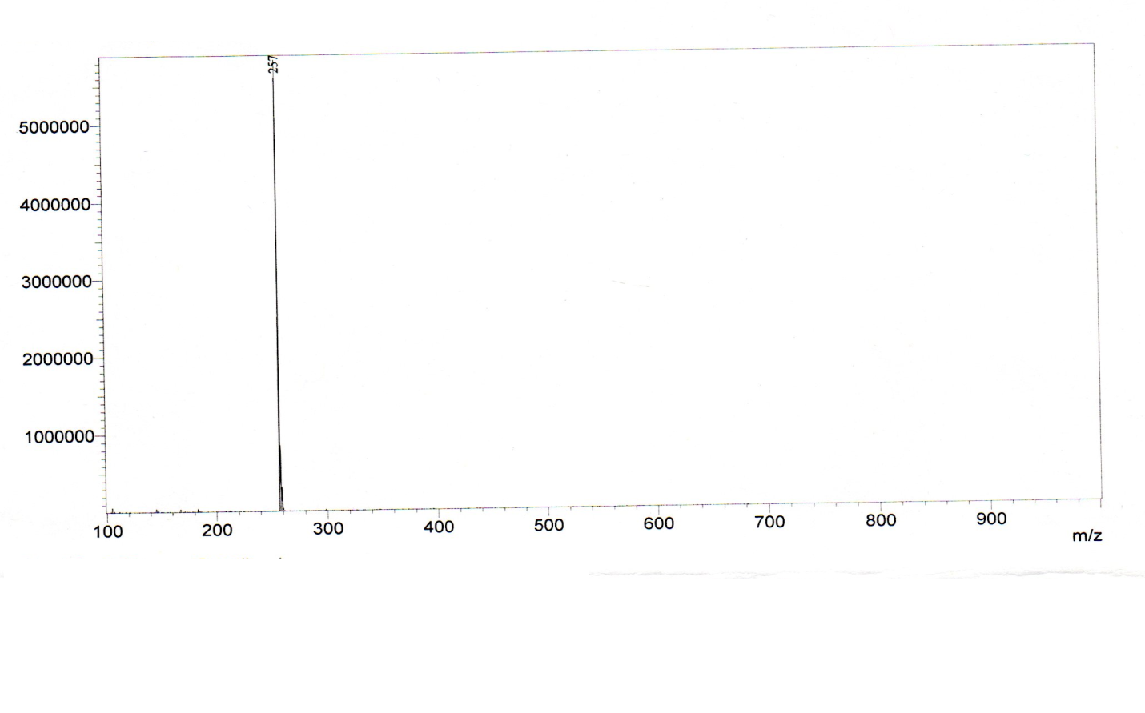

**FTIR Spectra of 2-(4-chlorophenyl)-1,3-benzothiazole (1f)**



**1H NMR Spectra of 2-(4-chlorophenyl)-1,3-benzothiazole (1f)**

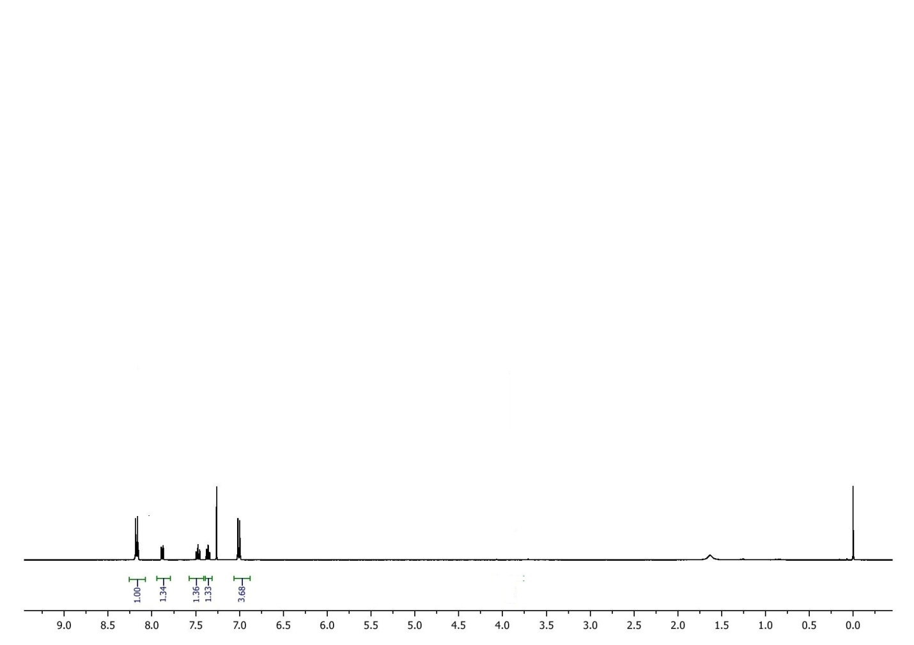

**13C NMR Spectra of 2-(4-chlorophenyl)-1,3-benzothiazole (1f)**

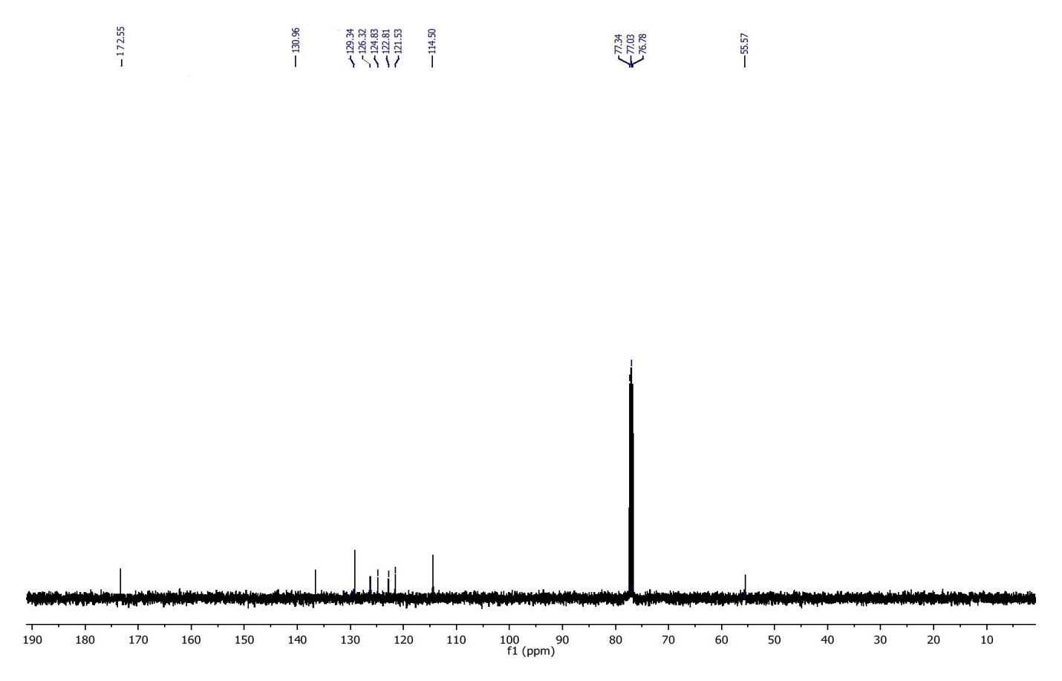

**Mass Spectra of 2-(4-chlorophenyl)-1,3-benzothiazole (1f)** 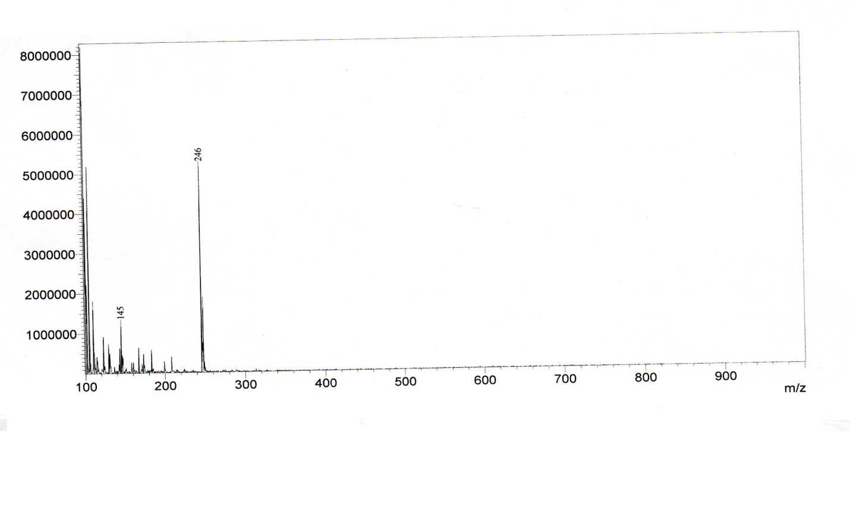

**FTIR Spectra of 2-(4-chlorophenyl)-1,3-benzothiazole (1g)**



**1H NMR Spectra of 2-(4-chlorophenyl)-1,3-benzothiazole (1g)**

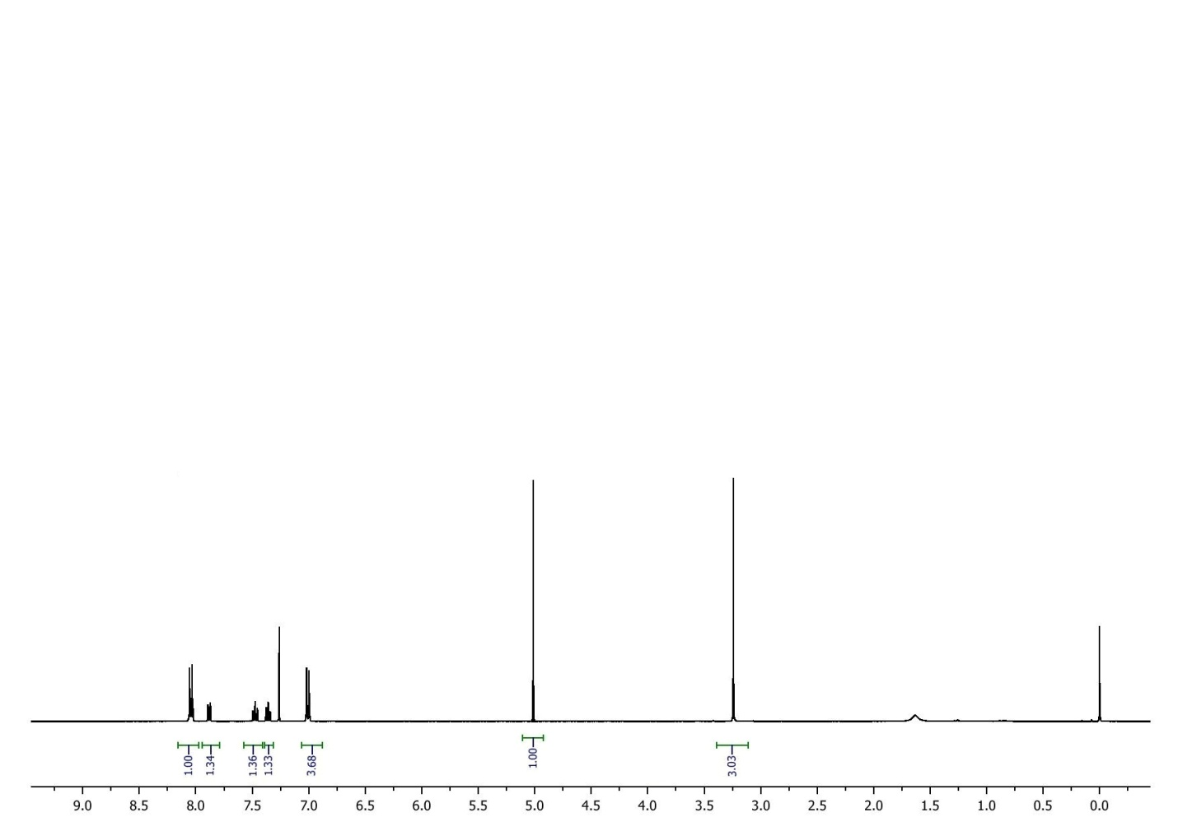

**13C NMR Spectra of 2-(4-chlorophenyl)-1,3-benzothiazole (1g)**

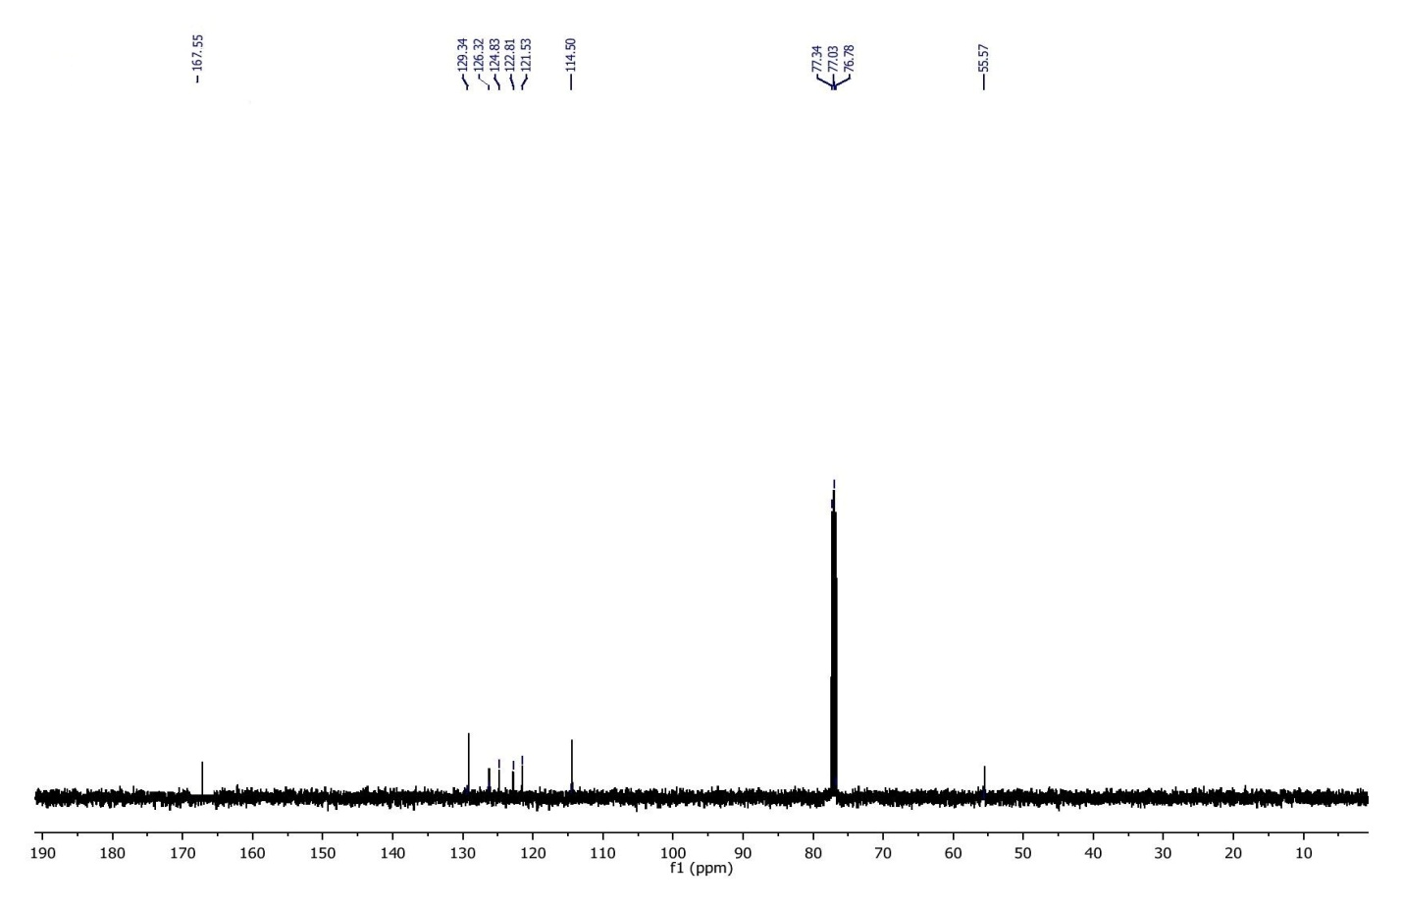

**Mass Spectra of 2-(4-chlorophenyl)-1,3-benzothiazole (1g)**

